ENGR101

Cover Sheet

Assignment 1

Name:

ID Number:

Username:

Workshop Number:

Due Date and Time: **20th of March, 3pm**

**Declaration**I confirm that the submission attached to this cover sheet is entirely my own work (apart from general verbal discussion with other students).

Signed:

**Return of work after marking (TICK ONE ONLY)**

|  |  |
| --- | --- |
| **□** | I agree to this work being returned to me in a pool of other students’ work, with the markers’ comments and mark being hidden from casual view. |
| **□** | I request that this work be treated as strictly confidential between the Department and me, and returned directly to me, upon providing suitable identification. |

**Marking Schedule**

**Content (Summary, Introduction, Technical Information, Conclusions)**

Content does not relate well to the subject, very little useful information. 1, 2

A small amount of content but insufficient to meet the aim of the report. 3

Good but some sections poor or minimal information. 4

Mostly good but room for improvement in one aspect. 5, 6, 7

Clear content, good summary, full of relevant information, good conclusion 8, 9, 10

**Grammar (grammar, punctuation, spelling, word choice)**

There are a number of different problems in grammar, spelling and/or punctuation, and communication is not effective or report is difficult to read and understand. 1

Readable but a number of improvements are possible. 2

A small number of improvements are possible. 2.5

Correct in all aspects. Difficult to improve further 3

**Format (Consistent typographical standard, spacing, headings)**

Inconsistent or distracting formatting that makes reading difficult. 1

Room for improvement 2

Very effective format that makes reading easy. Paragraphs correct, title page. 3

**Graph(s) (Clear, axes labelled, appropriate caption underneath)**

No graphs or very many improvements required 0

Room for improvement 1

Very clear, uncluttered, professional appearance, appropriate caption. 2

**Table(s) (Clear, uncluttered, units shown, appropriate caption above)**

No tables or very many improvements required 0

Room for improvement 1

Very clear, uncluttered, professional appearance, appropriate caption above. 2

**Citation and Referencing (Range of sources, citations, references)**

Not cited within text or referenced at all or very poor citation. 0

Only one of the three parts (range of sources, citations, references) has been done well. 1

Two parts done well or room for improvement. 1.5

Proper APA citation and referencing format used. All references are cited in the report.   
A good range of sources (≥ 5) are used. 2

**Penalties: no marking sheet (-1), word count (-1, -2)**

**Total Mark /22**

Marker’s initials:

Title

Student Name

ENGR101

Foundations of Engineering

2017

University of Canterbury

# Summary

The summary should seldom be longer than one page. About ½ a page is good for the first assignment. It should contain an overview of methods, significant results and important conclusions that resulted from the work.

In the report line spacing of 1.5 is good with a line space between paragraphs. Normally the first line of paragraphs is not indented. Some people prefer fully justified paragraphs but others like left justified. This document uses Word styles. Word styles are helping you to create a professional looking report with ease.

Normally in reports, you would find the summary by itself on a single page. There is no need to insert line breaks until a new page is reached. Use the keyboard shortcut CTRL + ENTER to insert a page break. Sometimes it is easier to format a document by showing hidden formatting signs. Click on ¶ in the Paragraph section of the Home ribbon or press CTRL + *.

Table of Contents

The contents table below was automatically created by Word. To update page numbers and headings right click on the table of contents list and choose “Update Field”, tick “Update entire table” and click OK. In case the content table is deleted, it can be created by opening the Reference ribbon and clicking on the Table of Contents Button.

Summary i

Introduction 1

ENGR101 report guidelines 2

This document uses sections. With sections you can separate different parts of the document. This is convenient when using different page numbering styles. Section can be created by opening the Page Layout ribbon and clicking on the Breaks button.

# Introduction

This document can be used as template for the first ENGR101 assignment. If you are not familiar with the report formatting recommendations in ENGR101 or with Microsoft Word keep on reading.

In case, you want to start writing your report straight away please delete the figure, table and their captions. Once completed right click on the Report Layout Information Style in the Style section of the Home ribbon and choose Select all xx Instances. Then delete the highlighted text and save the file under a new file name (e.g. “ENGR101 Assignment 1 username.docx”).

# ENGR101 report guidelines

The report must be word-processed, using 11-point Arial font or 12-point Times New Roman font (or similar), with 1.5 line spacing on A4 sheets of paper, with 2.5 cm margins all around. You may print double-sided. The upper word limit for the report is 1000 words. If this word limit is exceeded there will be penalty marks. (Please do not request a higher word limit.) The title page, references, and appendices are not included in the word limit. (A word limit, rather than a page limit, has been given so that you are free to format your report for ease of reading.) The word count of the report must be stated at the end of the report (In MS Word, Word Count on the Review ribbon. If you highlight the sections that contribute to the 1000 word count limit, “Word Count” won’t include the non-highlighted sections e.g. Title, references, etc.).

You will be awarded marks not only for the information you present, but also for the standard of your writing and the demonstrated use of a range of information sources.

The report should include:

* A completed ENGR101 cover sheet and marking schedule for assignment 1
* A title page with your name
* Summary
* Introduction
* Technical Information
  + Define Success
  + The Selected Solution
  + Test
* Conclusions
* References
* Appendices (if required, but these will not be marked)
* Word count

The title page should be a single page. After the Summary, the subsequent sections do not need to start on a new page.

*Hint for values and units:* When writing values there is normally a space between the number and units, e.g., 12.5 cm rather than 12.5cm, but there is not space before %, e.g., 85.2%, because % is not a unit but as abbreviation for /100. In the case that the value and its unit are on different lines create a space that does not split across a line by using CRTL + SHIFT + Spacebar.

Word styles

Paragraphs play different roles in documents, such as titles, headings, text or captions. A report should be consistently formatted to look professional. With Word formatting different paragraphs is easy by using styles.

Bullet and numbered lists

Bullet and numbered lists indicate important information in a report and improve its readability. They can be created by clicking on the Bullets button in the Paragraph section of the Home ribbon.

Tables

Tables should only be used to present complex or large sets of data containing several variables. Tables should be citied in the report prior its placement, as shown for Table 1. Table caption can be automatically generated by right clicking on the crosshair, which is visible in top left corner of the table when the mouse cursor is hovering over the table, and selecting “Insert Caption”. All tables must include a caption, which need to be above the table.

Table : ENGR101 time table.

|  |  |  |
| --- | --- | --- |
|  | Day | Time |
| Workshop | Monday | 9:00 – 11:00 |
| Lecture | Friday | 12:00- 14:00 |

Figures

Figures can graphs, pictures, photos or drawings. As for a table, a figure must be referenced before it appears. Ideally text in figures should have a similar font size to the body text, as shown in Figure 1. Figure captions are below the figure and can be centred.

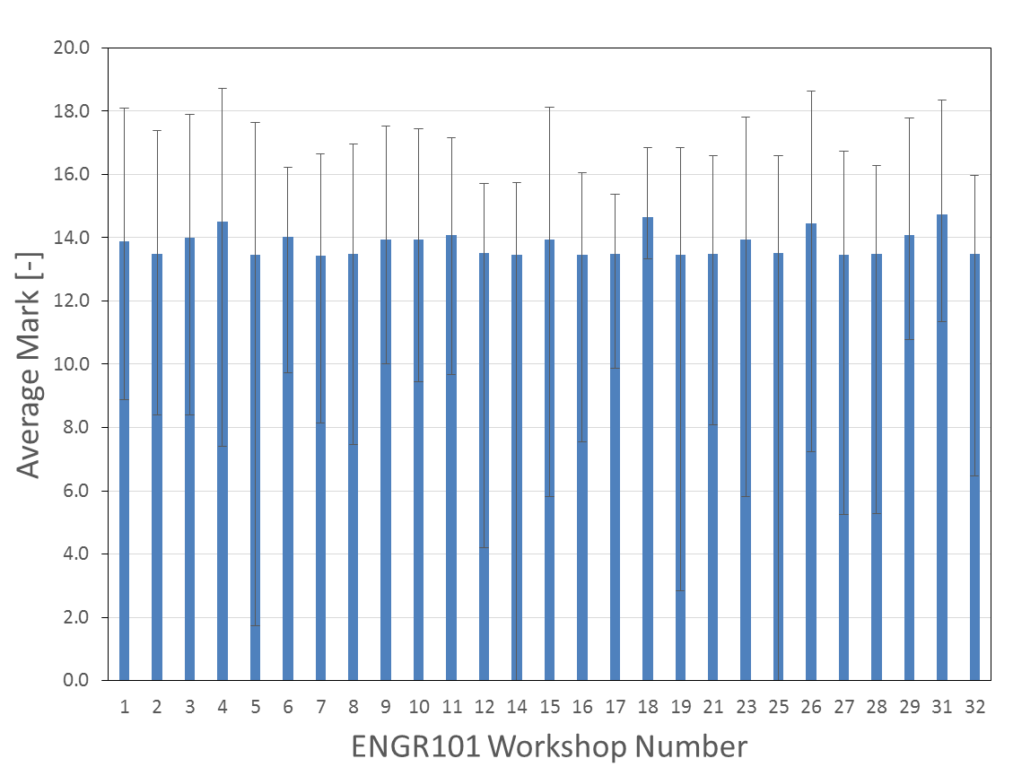

Figure : Distribution of average marks for the first ENGR101 assignment in 2015.

References

References should follow the APA standard (see ENGR101 Web Resources on the ENGR101 Learn pages). All sources of your information must be cited in your text and a full list of references must be included. A guide to referencing is linked from the ENGR101 Learn resource “ENGR101 Web Resources”. Direct quotes are discouraged but they are sometimes appropriate. Referencing of online encyclopaedias, such as Wikipedia, is discouraged; you should use the original source of the information if possible. It is likely that you will find data on the web that is not supported by scientific analysis. Be sure not to place too much reliance on unsupported data. Recommend ENDNOTE

Word count: xxxx (The upper word limit for the report is 1000 words.)